

Dr. Jerry, Pennington inc.

2020-05-28

Dr. Pennington

PSC 7398, Box 7457, APO AA 39697

Phone: 7108513558

Fax: 727706983

**Re:** Anna, Kelly

**PHN:** 6925661712

**Birthdate:** 12-Aug-1975

**Address:** 87033 Samantha Pines Apt. 386, Port Joshua, MT 24924

**Patient number:** 6742412360

To Whom It May Concern:

This is a medical letter to state the above patient is pregnant with expected delivery date of 09-Aug-2025. Hoping this information is satisfactory for your requirements.

Thank you.

Sincerely,

Dr. Jerry, Pennington

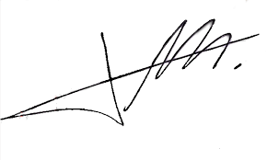

FRCS© NCMP

Clinical Assistant Professor, UBC

Department of Obstetrics and Gynecology SMH